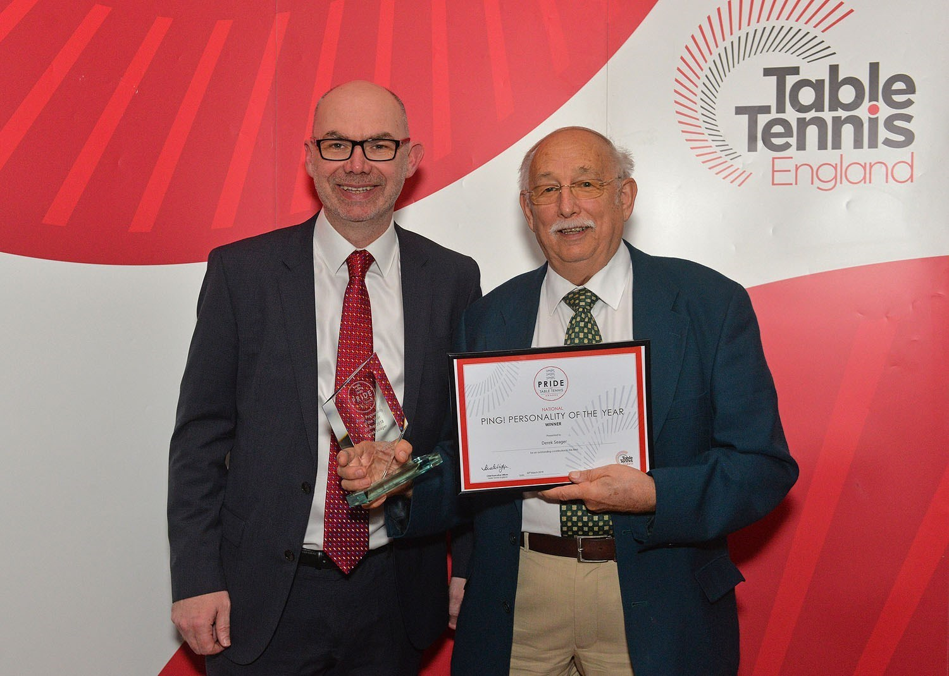
Derek Seager (1946–2026)
Secretary and Chairman of Hampshire Table Tennis Association, and for many years the driving force of Aldershot and District Table Tennis Association.
The table tennis community has lost one of its most devoted servants with the passing of Derek Seager.
For more than six decades, Derek’s life was intertwined with the sport he loved. He was not someone who sought recognition or applause; instead, he quietly dedicated thousands of hours to developing players, supporting clubs, organising leagues and ensuring that table tennis flourished wherever he could make a difference.
Derek’s journey in the sport began during the 1960s while living in Scotland, where he first discovered a love for table tennis at Rosyth Dockyard. Following a move south to Wiltshire in the late 1960s, he continued playing at Corsham Community Centre. It was there that he met the woman who would become his wife, Andrea. Introducing her to the sport, Derek quickly demonstrated the coaching ability that would define so much of his life, helping Andrea become the Avon Ladies Champion during the 1970s while the pair also enjoyed success together in mixed doubles.
Recognising his passion for developing others, Derek completed his coaching qualifications during the 1970s and devoted much of his spare time to coaching throughout Wiltshire, always encouraging new players to discover the enjoyment of table tennis.
In 1982 Derek moved to Hampshire and joined the Aldershot & District Table Tennis League. Playing for RAE (now Cody Sports & Social Club) whilst working at the Institute of Aviation Medicine, he quickly became deeply involved in league life.
During the 1980s Derek became Aldershot’s Coaching Officer, working alongside Father Bernard Rowley and Vera Hutchinson at coaching sessions held in Frimley Church Hall. Those evenings became the foundation for what would grow into one of the area’s most successful coaching programmes. As numbers increased, the sessions eventually outgrew Frimley and moved to Collingwood College during the late 1990s and early 2000s.
True to Derek’s character, the emphasis was never on making money. Charges were kept deliberately low, simply to cover the cost of hiring the hall, while any surplus was reinvested into better tables, robots, equipment and facilities to provide the highest standard of coaching possible. The coaching sessions continue to this day, welcoming players of every age and ability, creating friendships and nurturing talent in exactly the way Derek always intended.
Over the decades Derek served the Aldershot League in almost every committee role imaginable. Whether acting as Coaching Officer, committee member or helping steer difficult decisions when league participation declined, he was a constant source of stability, common sense and quiet leadership. His overriding ambition was always the same: to ensure the league continued to thrive for future generations.
His contribution extended far beyond Aldershot. Derek devoted an enormous amount of time to Hampshire Table Tennis Association, serving in numerous roles over many years, including Secretary and Chair. He also managed the Hampshire Men’s Team during the 1990s, organised the Hampshire Inter-Town competitions at Redbridge, and worked tirelessly to bring elite coaching opportunities to aspiring young players, inviting leading figures from the England set-up including then England Head Coach and former World No. 4 Matthew Syed to inspire the next generation.
His coaching influence reached far and wide. Several of the players he coached progressed to represent England, but Derek took just as much satisfaction from helping complete beginners gain confidence as he did developing elite performers. To him, every player’s improvement was a success worth celebrating.
Even when mobility issues made life more difficult, Derek remained committed to the coaching programme at Collingwood College. Although he could no longer do everything physically, he continued to mentor, organise and encourage others to become coaches themselves, ensuring the future of the programme he had helped build.
Away from organised table tennis, Derek’s enthusiasm never switched off. Family holidays often included entering the hotel table tennis tournament, but for Derek the competition was only the beginning. More often than nothe would spend hours afterwards helping the people he had just met, offering tips, encouragement and coaching simply because he wanted them to enjoy the game even more.
In 2019, Derek’s decades of selfless dedication were recognised nationally when he received Table Tennis England’s prestigious Ping! Personality of the Year Award. Characteristically humble, Derek said he felt honoured to receive the award for something he “just did because I love it.”
Those words summed him up perfectly.
To Derek, table tennis was never simply a sport or a hobby. It was a lifelong passion, a community and a way of bringing people together. The countless evenings, weekends and bank holidays he freely gave to coaching, organising competitions, attending committee meetings and helping others were never viewed as a sacrifice they were something he genuinely loved doing.
Above all, Derek will be remembered for his generosity with his time, his patience, his encouragement and his unwavering belief that table tennis should be open to everyone.
His legacy is measured not only in trophies or titles, but in the generations of players, coaches, volunteers and friends whose lives he enriched.
The tables will still be full, the coaching sessions will continue, and players will continue to develop but they will do so thanks in no small part to the foundations Derek spent a lifetime building.
He will be greatly missed and fondly remembered by all who had the privilege of knowing him.

